Chapter 14, Solution 17.

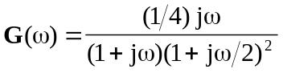

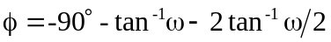

The magnitude and phase plots are shown below.
G_{dB}
-20
20
w
100
1
10
0.1
-40
-12

f
-90°
90°
w
100
1
10
0.1
-180°

